申请须知：
Guide to Application:
1.护照需为清晰、完整的彩色扫描件，内容包括信息页及其上一页
例如：
1. The color scanned passport, including the information page and its previous page, should be as clear and complete as the following picture shows:
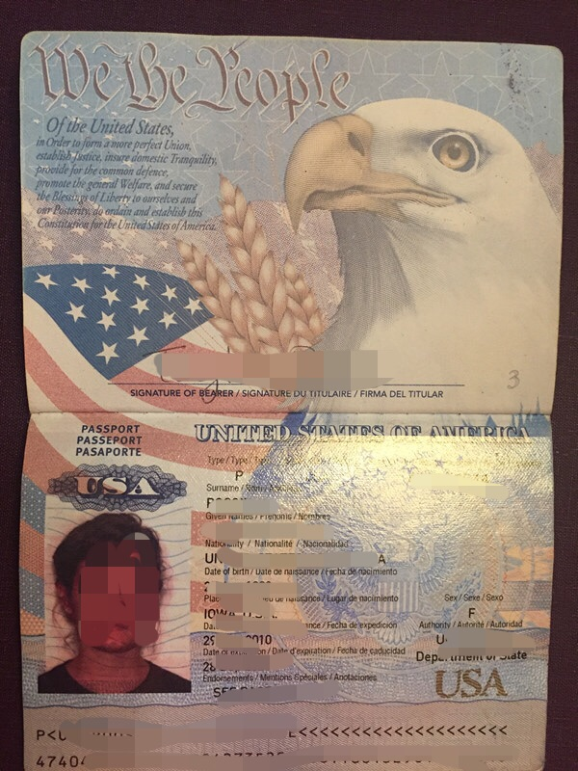
- 姓名必须严格按照护照上填写，不得缩写，不得省略中间名。姓或名为空的，可以留空或者填写“-”“.”。
2. The name must be the same as that in the passport. Abbreviations or omissions of the middle name are not allowed. If there is no family name or first name, please leave it with a blank, ‘-’ or ‘.’.
- 在华的申请者需要提交有效签证的彩色扫描件和最近一次入境章所在页面彩色扫描件。
3. Applicants already in China must submit color scanned visa within the validity period with the latest entry stamp.
4.对于未满18岁的申请者，须提交法定监护人材料如监护人证件、收入证明、监护委托书等（学生任意上传一样即可）。
4. Applicants under the age of must submit valid documents of legal guardians, such as ID card, certificate of income and letter of guardianship. (Either one is acceptable)
5.所有申请者需如实填写从高中至今的所有学习经历和工作经历，年份之间不得有空缺。（韩国学生需填写服兵役情况）
5. Applicants must fill in all the study and work experiences from high school so far without gaps. (Korean applicants should list the period of military service)
6.申请者提交的最高学历证明必须为毕业证书或学位证书的扫描件（任何相关证明无法作为申请者的最高学历证明，必须为毕业证书或学位证书）如尚未取得，请提交前置学历证书。
6. Applicants must submit either scanned diploma or certificate of the highest degree. If the degree certificate is not acquired yet, the previously acquired academic certificate must be submitted. (Any other relevant documents are unacceptable)
7.非英文的学历证明要提交原件+经公证的中文或英文的译文。
7. If the academic certificate is non-English, the original must be attached with notarized Chinese or English translations.
8.申请者的最后学历请填写申请者的前置最高学历。
8. The highest level of education must be filled in the previously acquired degree.
9.学习成绩单。中英文以外文本须附经公证的中文或英文的译文。
9. Academic transcripts (written in Chinese or English); transcripts in languages other than Chinese or English must be attached with notarized Chinese or English translations.
10.体检证明。所有申请者须提交《外国人体格检查表》复印件（原件自行保存，可登录http://www.csc.edu.cn/studyinchina 或 http://www.campuschina.org 下载，须英文填写）。申请人应严格按照《外国人体格检查表》中要求的项目进行检查。缺项、未贴有本人照片或照片上未盖骑缝章、无医师和医院签字盖章的《外国人体格检查表》无效。鉴于检查结果有效期为6个月，请申请人据此确定本人进行体检的时间；
10. Applicants must submit Foreigner Physical Examination Form (photocopy) written in English. (downloaded from http://www.csc.edu.cn/studyinchina or http://www.campuschina.org ) The physical examinations must cover all of the items listed in the Foreigner Physical Examination Form. Incomplete forms or forms without the signature of the attending physician, or the official stamp of the hospital, or a sealed photograph of the applicant are considered as invalid. Please carefully plan your physical examination schedule as the result is valid for only 6 months.
11.语言证明。本科生提交HSK4，硕士、博士生中文授课项目需提交HSK4级以上证书；英文授课项目需提交托福75或雅思6分相关证书。申请英文授课项目：母语或官方语言为英语的申请者可不用提交语言证明；前置学位为英文授课的申请者可用相关证明代替语言证明。
11. Language requirement.
For Chinese-taught programs: Undergraduates should submit HSK 4 Certificate; master's students and doctoral students should submit certificate above HSK 4.
For English-taught programs: TOEFL: 75 or IELTS: 6.0.
Applicants whose native language or official language is English don't need to submit certification of language proficiency; applicants whose previous degree programs are taught in English may use relevant documents to certify the language proficiency.
12.推荐信。申请攻读硕士、博士学位者和申请作为高级、普通进修生来华学习者，须提交两名教授的推荐信，用中文或英文书写。
12. Recommendation letters (written in Chinese or English). Applicants for the graduate programs, and senior and common scholar programs must submit two recommendation letters signed by professors.
13.来华学习或研究计划。用中文或英文书写。普通进修生和硕士生不少于1500字，博士研究生和高级进修生不少于2500字。
13. A Study Plan or Research Proposal (written in Chinese or English). This should be a minimum of 1500 words for common scholars and master's students, 2500 words for senior scholars and doctoral students.

